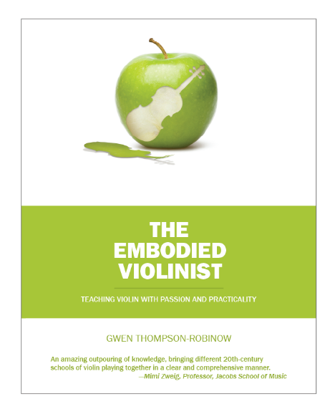
“Every violinist should buy this book.” — The Strad, July 2018

… viola, cello and bass players too!

TEACHING VIOLIN WITH PASSION AND PRACTICALITY
In this book, how to teach violin meets Zen and the Art of Motorcycle Maintenance. Teach violin through mindful awareness of body, breath, and musicality, and not only will students’ confidence evolve but so will their musical expression. This method helps students uncover their musical talent, develop technical accuracy, discern musical preferences, and evolve a broad musical palette. The 160 individual exercises are illustrated with many professionally rendered drawings and musical notation examples, including original manuscript samples created by the author’s own teachers (used with permission). Comments from former students throughout the book are eloquent testimony to the life lessons learned through this method, the group technique class in particular.
Gwen Thompson-Robinow has been developing this book since 2007 and has been evolving the idea of the "embodied violinist" for fifty years. Gwen continues to mentor students and teachers around the world.

LOOK INSIDE: https://www.embodiedviolinist.com/look-inside#inside-pages-2

